

UNVEILING MARKET INSIGHTS: ANALYSING SPENDING BEHAVIOUR AND IDENTIFYING OPPORTUNITIES FOR GROWTH

1. INTRODUCTION

1.1 Overview

* The goal of the field of marketing insights is to learn about and analyse the market.
* Unveiling marketing insights is a powerful tool for businesses to gain a competitive edge in today's dynamic market place.
* It is a crucial component of a successful business strategy.

1.2 Purpose

* Unveiling marketing insights plays a crucial role in helping businesses to make informed decisions, identifying opportunities and mitigating risks.
* In this way, it provides valuable evidence to take better decision around your longer term strategy as well as ways to future proof of our business.
* To make informed, data-driven decisions about a company's products, services, and overall business strategy.
* To determine the best way to position a product or service in the market, ensuring it meets the needs and expectations of target customers.
* To identify opportunities for developing new products or improving existing ones based on customer needs and market trends.

2. PROBLEM DEFINITION & DESIGN THINKING

2.1. Empathy Map

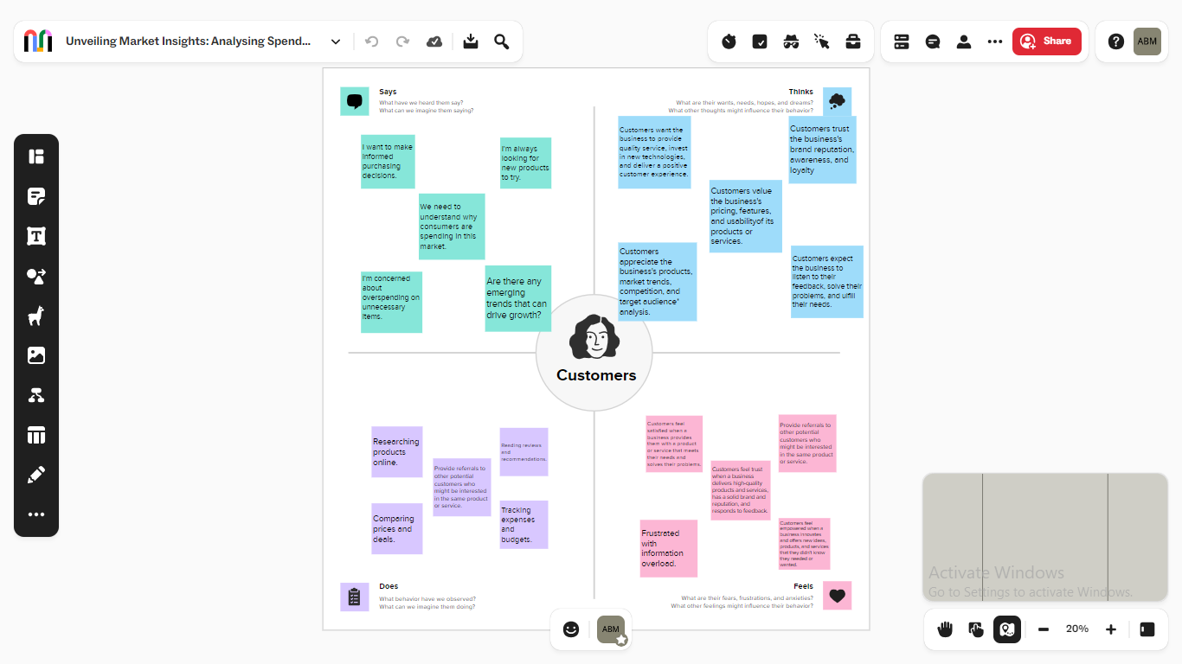

EMPATHY SCREENSHOT

2.2 Ideation & Brainstorming Map

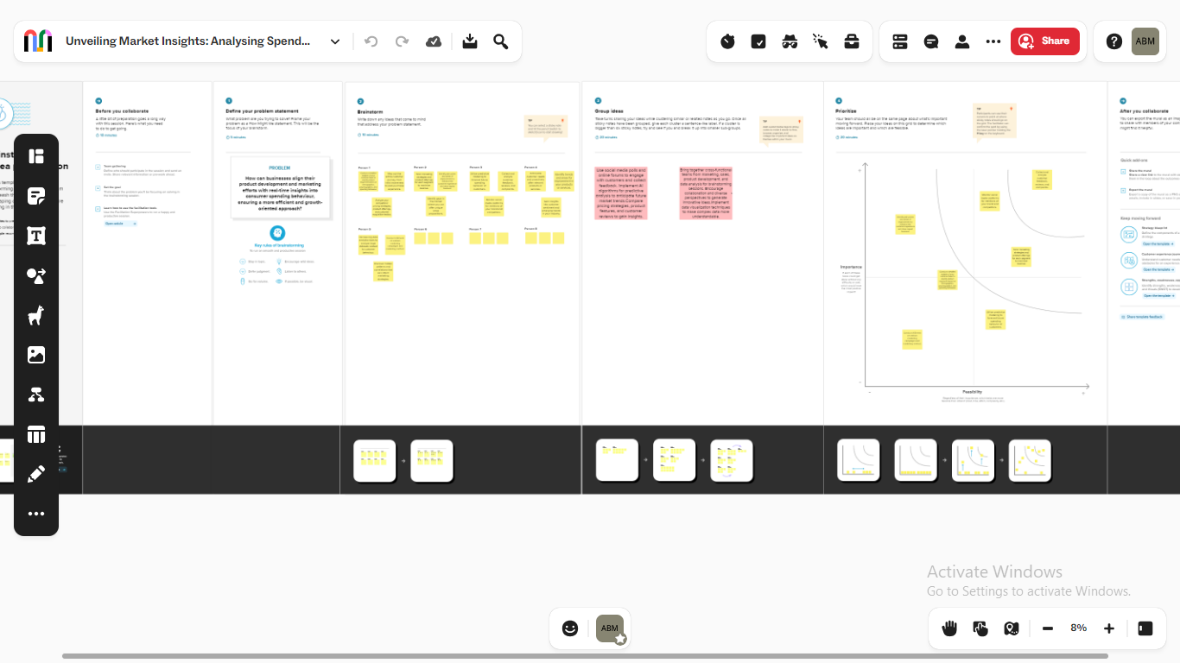

BRAINSTORMING SCREENSHOT

3. RESULT

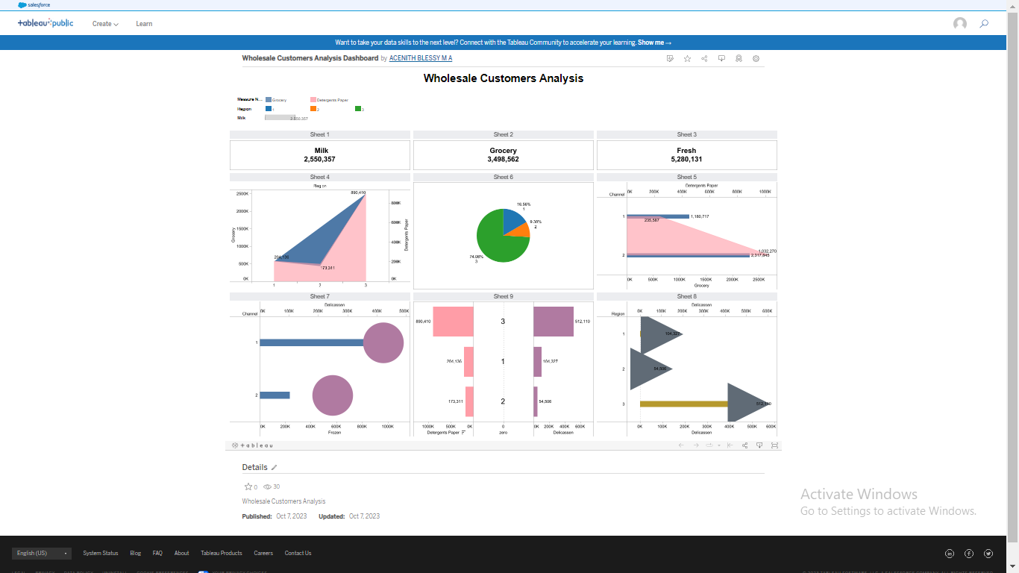

DASHBOARD SCREENSHOT IN TABLEAU PUBLIC

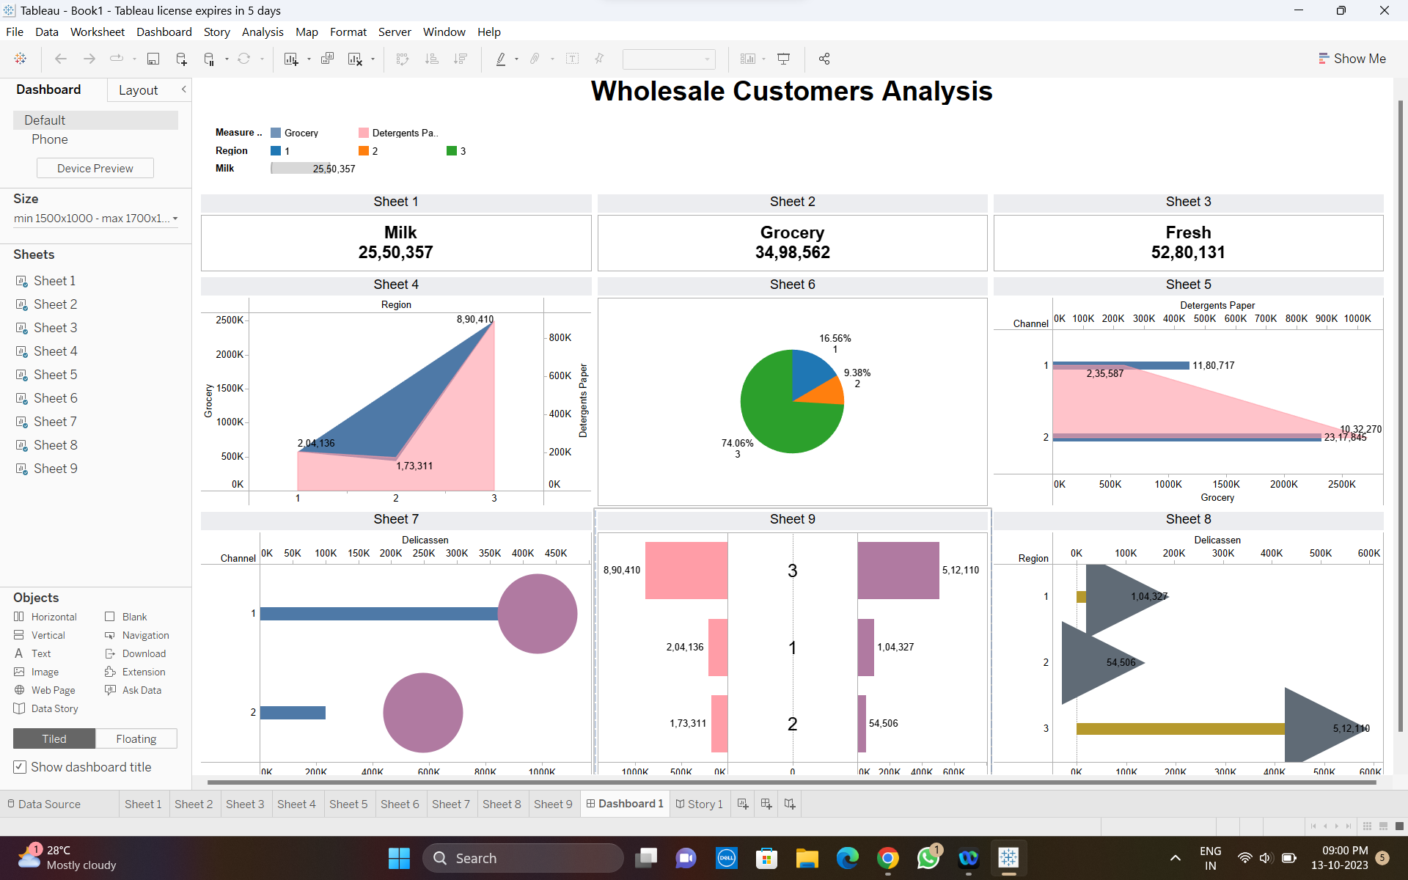

DASHBOARD SCREENSHOT IN TABLEAU DESKTOP

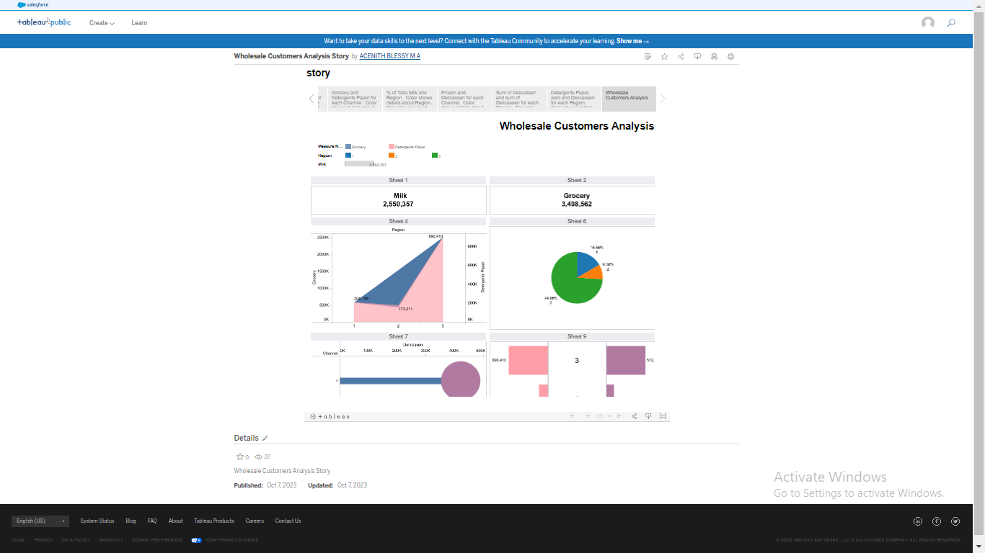

STORY SCREENSHOT IN TABLEAU PUBLIC

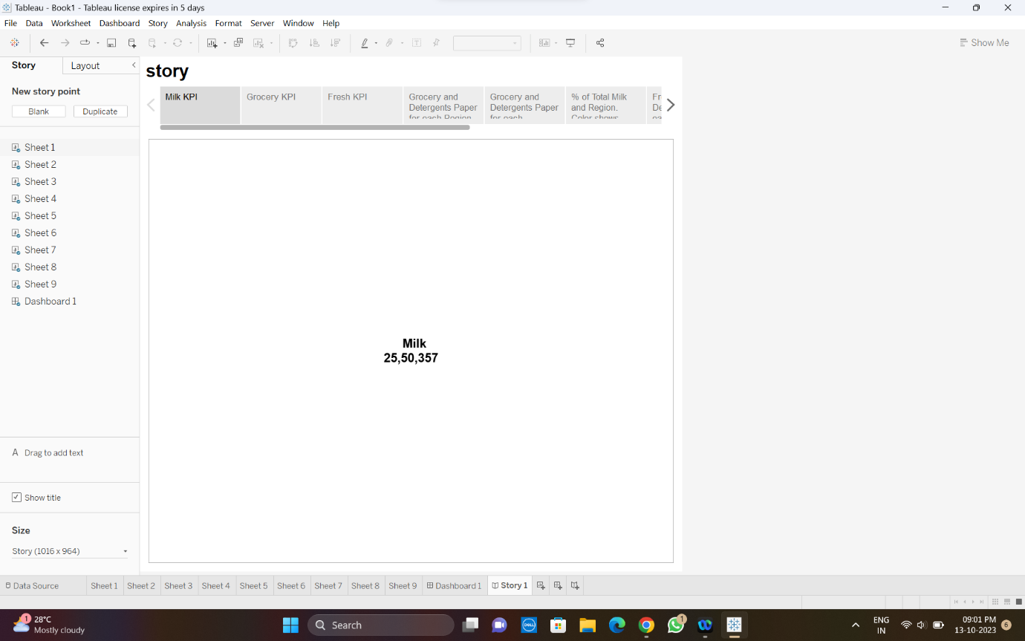

MILK KPI

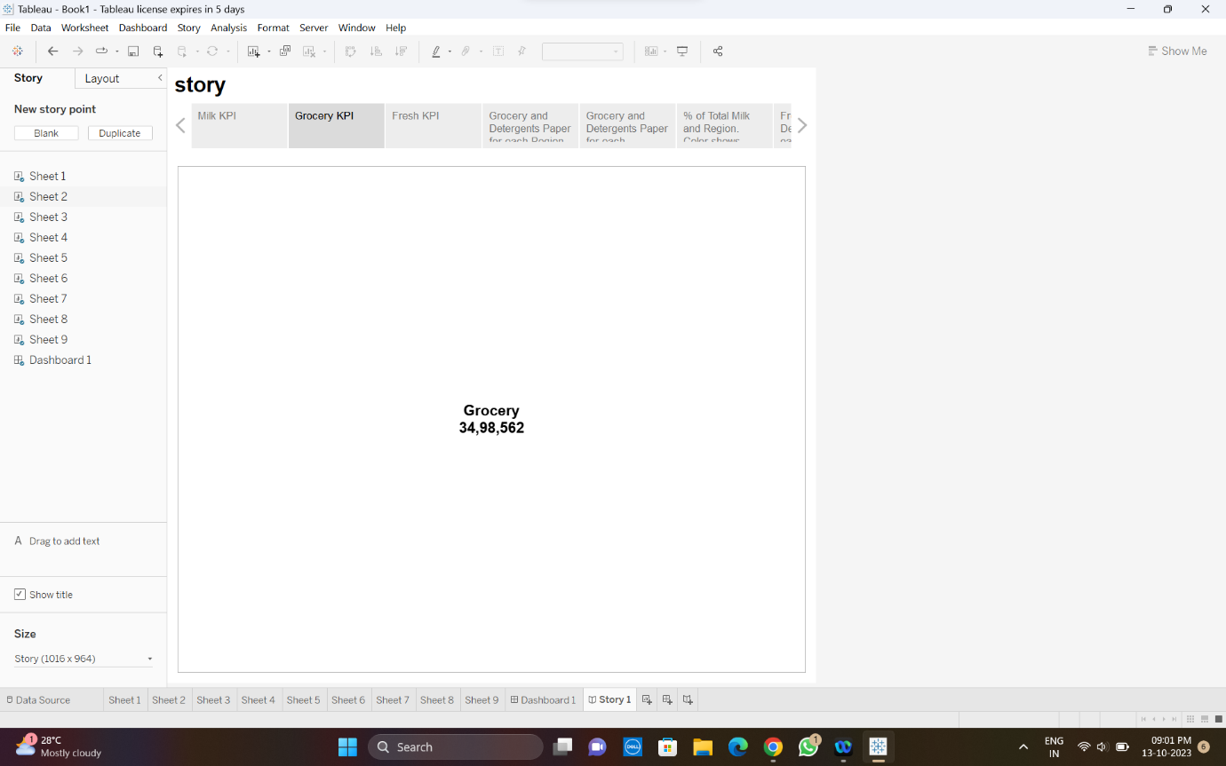

GROCERY KPI

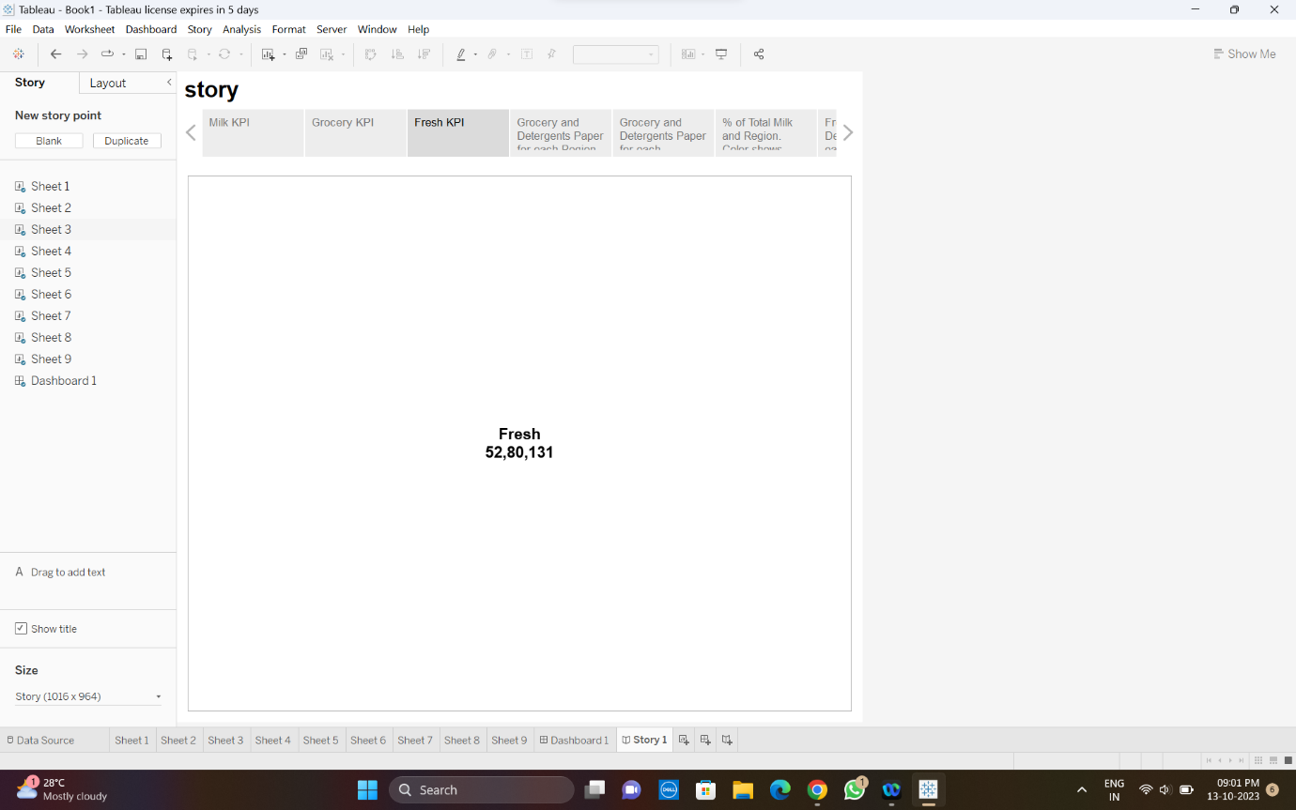

FRESH KPI

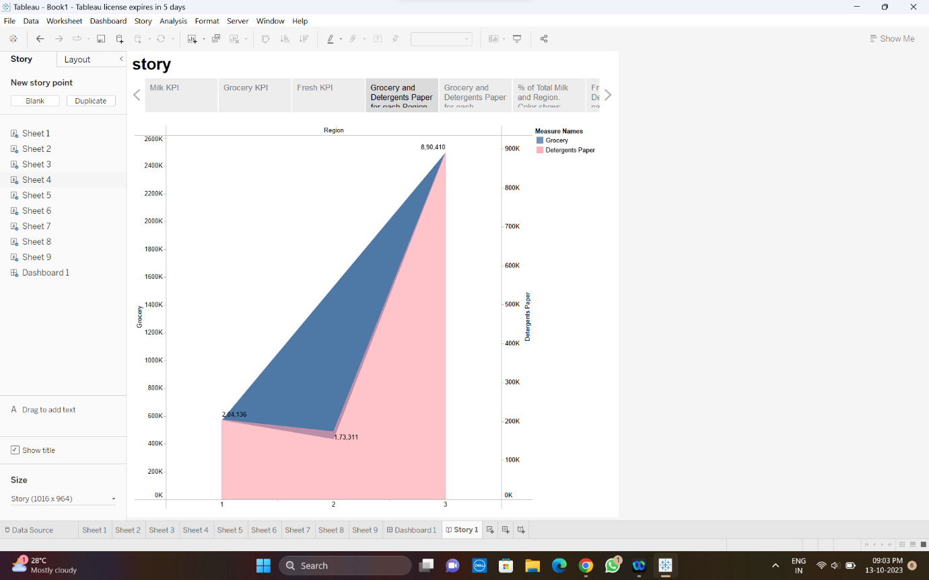

POLYGON AND AREA CHART

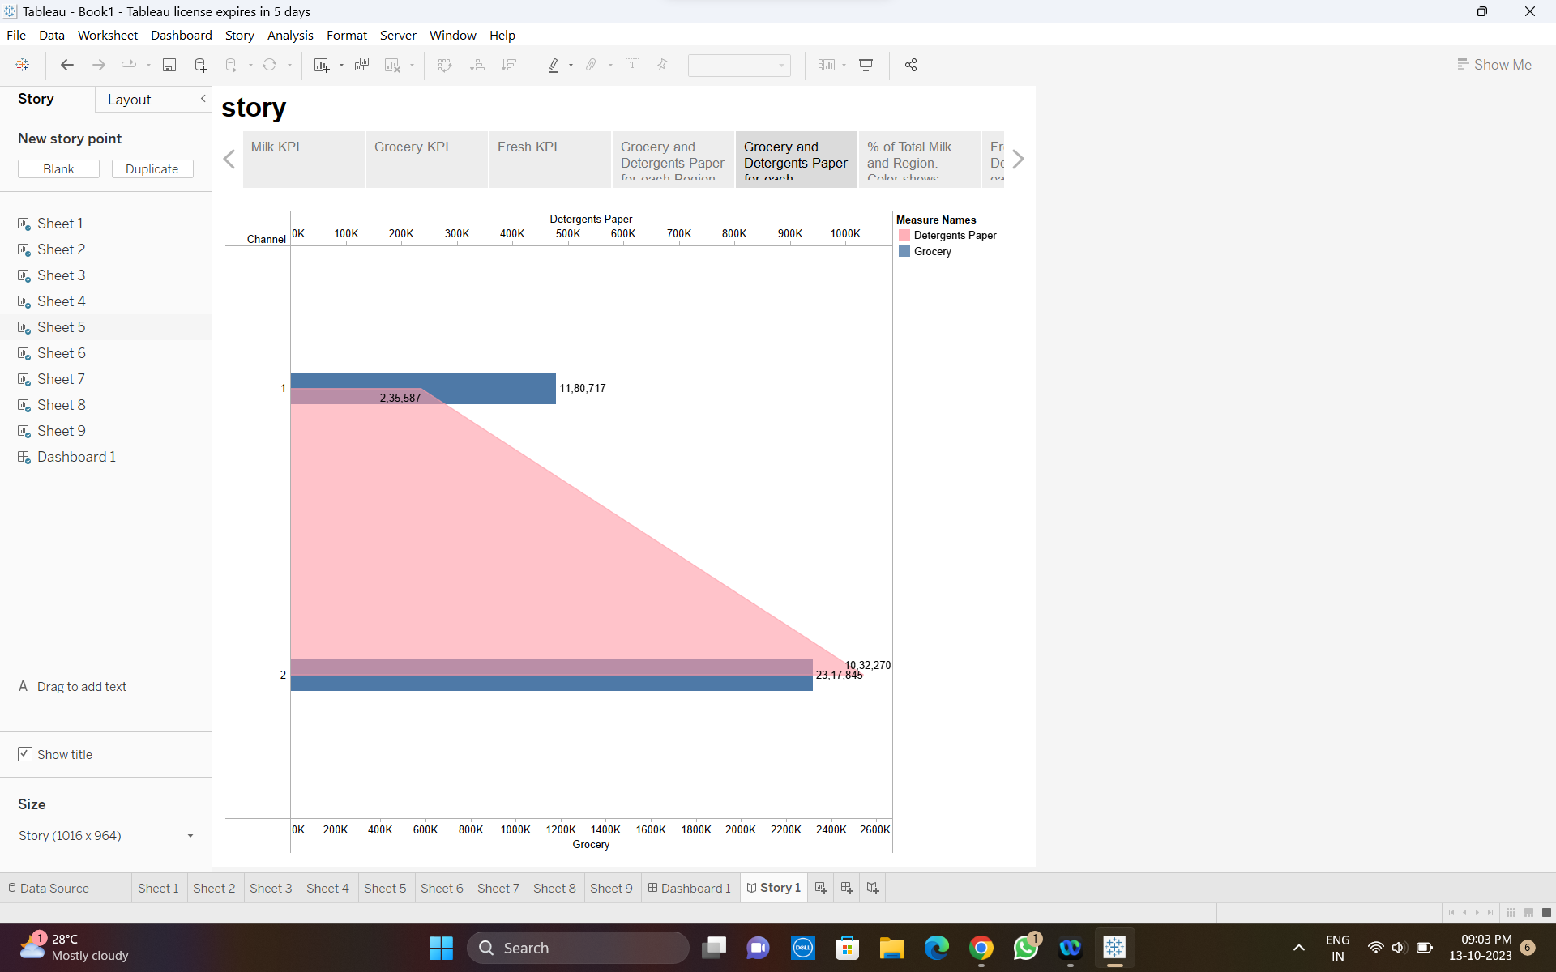

BAR AND AREA CHART

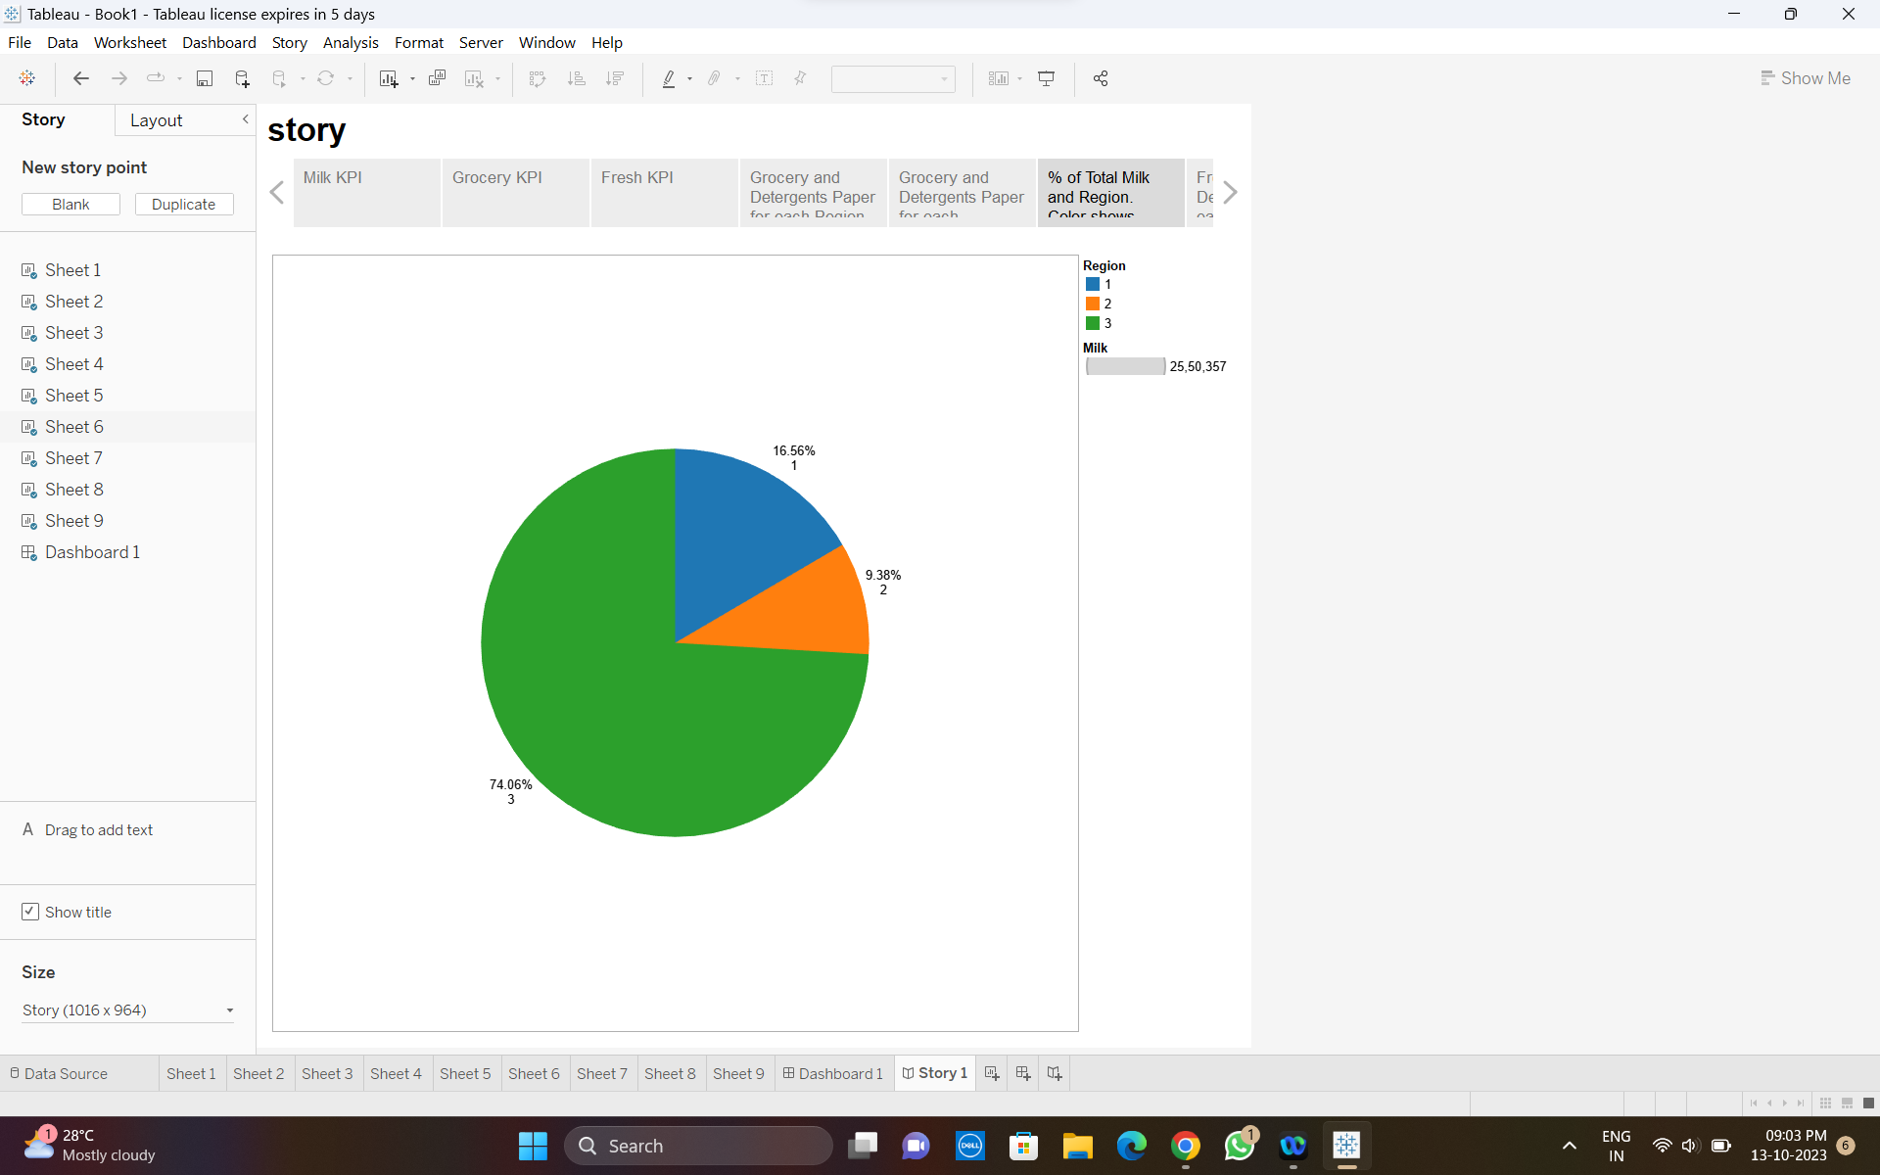

PIE CHART

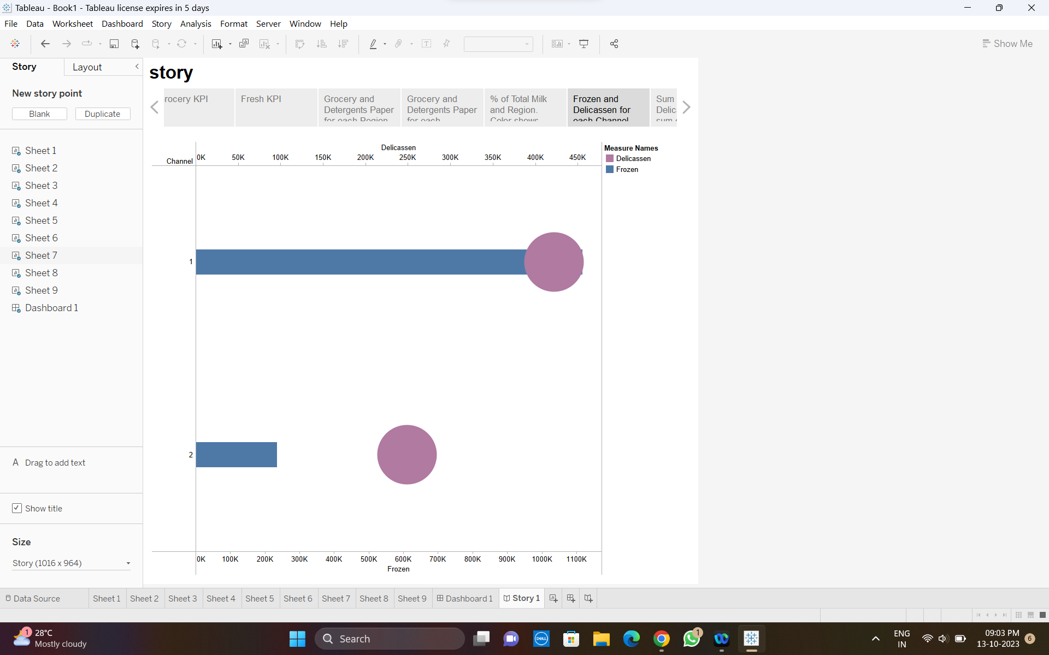

LOLIPOP CHART

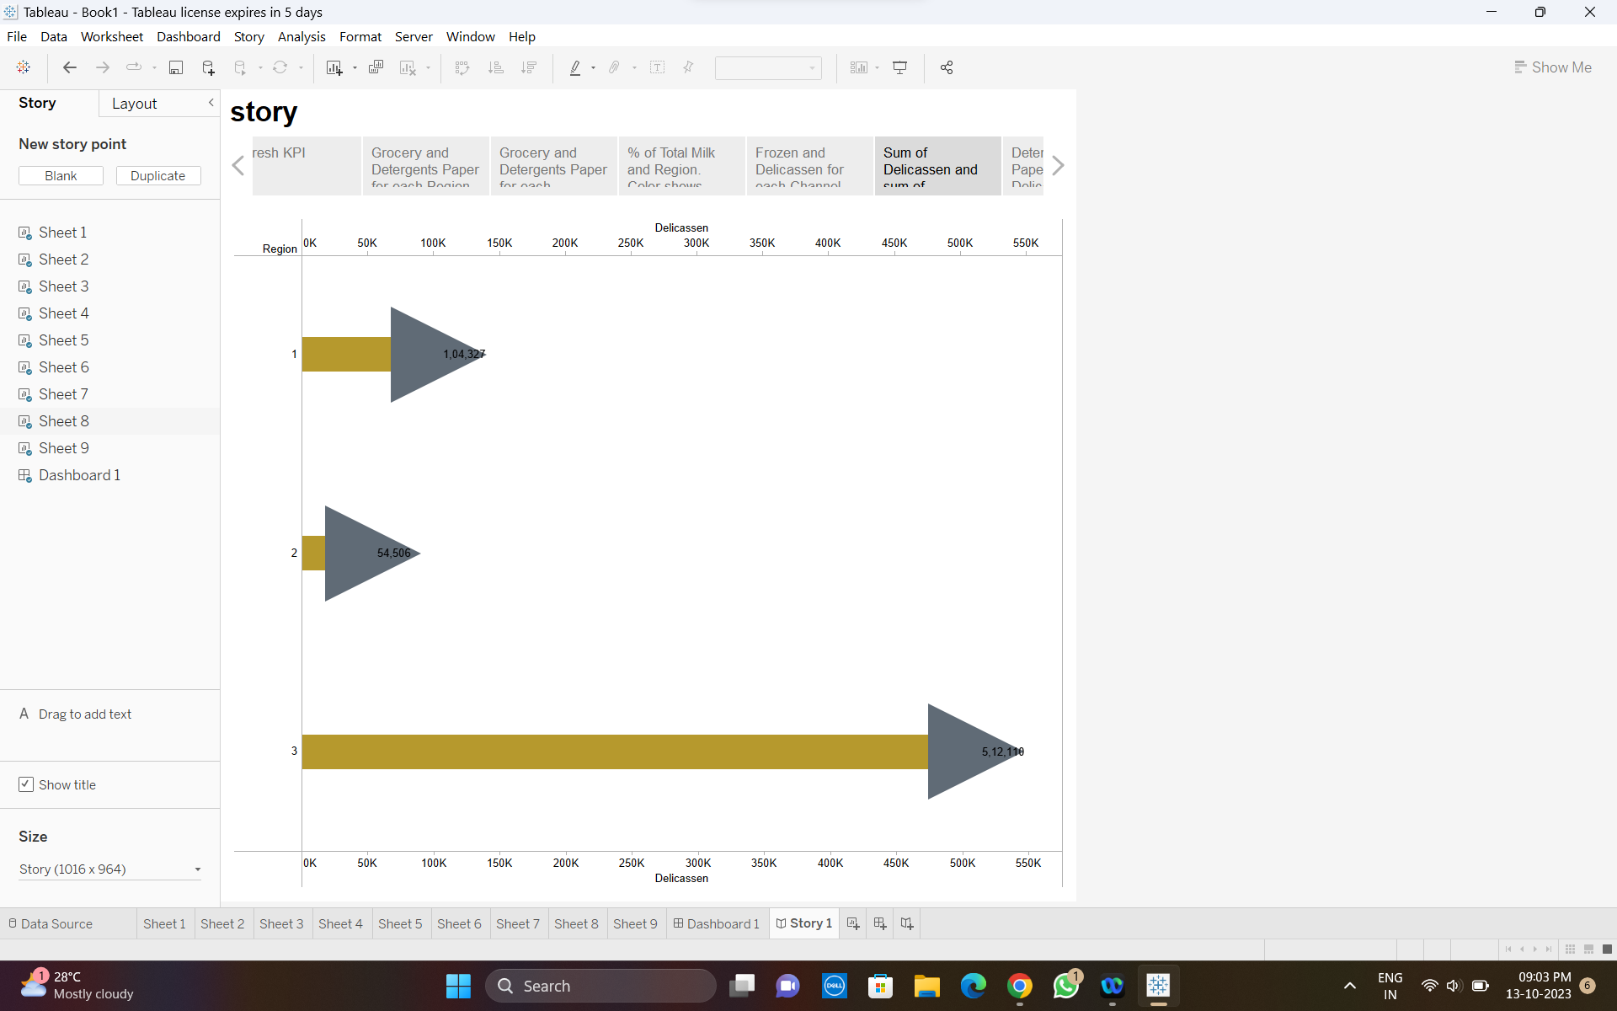

ARROW CHART

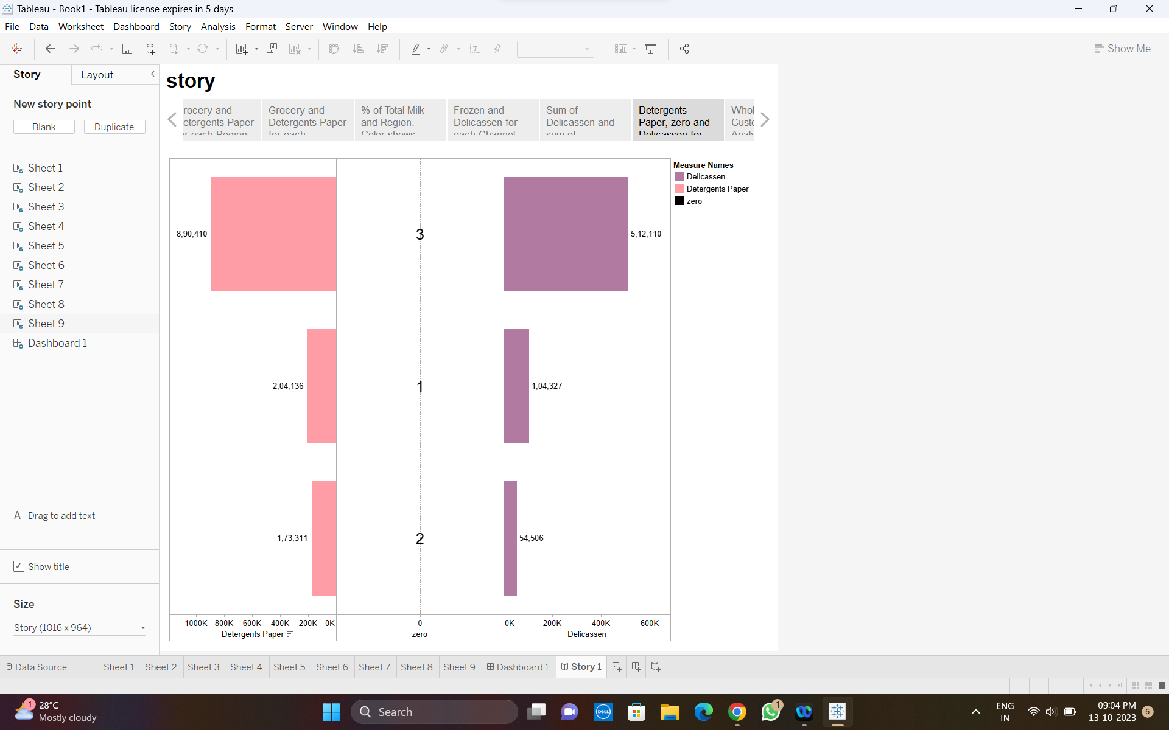

BUTTERFLY CHART

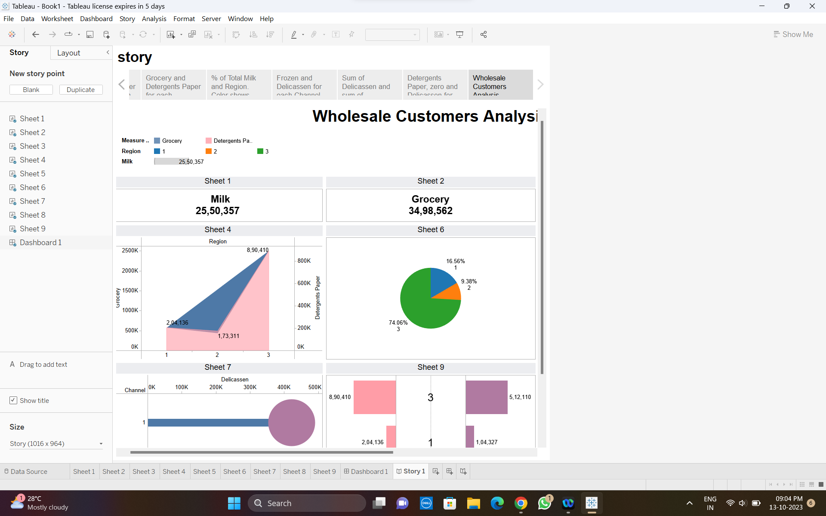WHOLESALE CUSTOMERS ANALYSIS

4. ADVANTAGES &DISADVANTAGES

Advantages

* It will eventually lead more sales and an increase in market share. Allows you to take more scientific approach to the market.
* Offers career opportunities.
* Helps to provide more suited solution to the consumers and outperform their competition.
* Marketing allows us to know customers better.
* Gives higher revenue.

Disadvantages

* One of the most common issues in marketing analytics is a surplus of incoming data.
* Forces us to spend a lot of time and effort to identify which information is most relevant.
* It can be expensive and information overload.
* Will not give success for all.

5. APPLICATIONS

* Retailers can use this solution to understand consumer spending habits, market trends and competitive landscapes.
* Banks and financial institutions can create reports to assess consumer savings and investment habits.
* Insights can help tailor financial products, targets specific customer segments and design marketing campaigns.
* Market growth is evident, with certain segments showing higher potential.
* Consumer preferences are shifting, emphasizing the need for personalization.
* Technological innovation and adaptability are critical for staying competitive.

6. CONCLUSION

* This analysis has shed light on essential market insights and consumer spending behaviour.
* The market landscape is ever-evolving and understanding these dynamics is key to capitalising ion growth opportunities.
* By assessing market size, completion, consumer demographics, purchase behaviour and preferences, we have uncovered several potential avenues for business expansion.
* The conclusions drawn can serve as a road map for businesses looking to adapt and thrive in a dynamic market environment.

7. FUTURE SCOPE

* Develop a strategic plan based on the insights you've gained. This should include marketing, sales, and product development strategies to capitalize on growth opportunities
* Emerging markets and new technologies that could create opportunities for your business.
* Stay updated on regulations, environmental concerns, and social trends that may impact.
* Map the entire customer journey, from awareness to purchase and post-purchase.
* Identify touch points and moments where customers make spending decisions. Use surveys, focus groups, and interviews to gather qualitative data about customer preferences, pain points, and unmet needs.